Listing Fraud Pre-Check
Designing a human-in-the-loop seller verification workflow to identify listing risk before a property is marketed.
PRODUCT  Seller Verification & Listing Fraud Pre-Check Platform | ROLE  Product concept, workflow architecture, decisioning design, requirements, AI-assisted MVP | STAGE  Working MVP / Pilot Ready

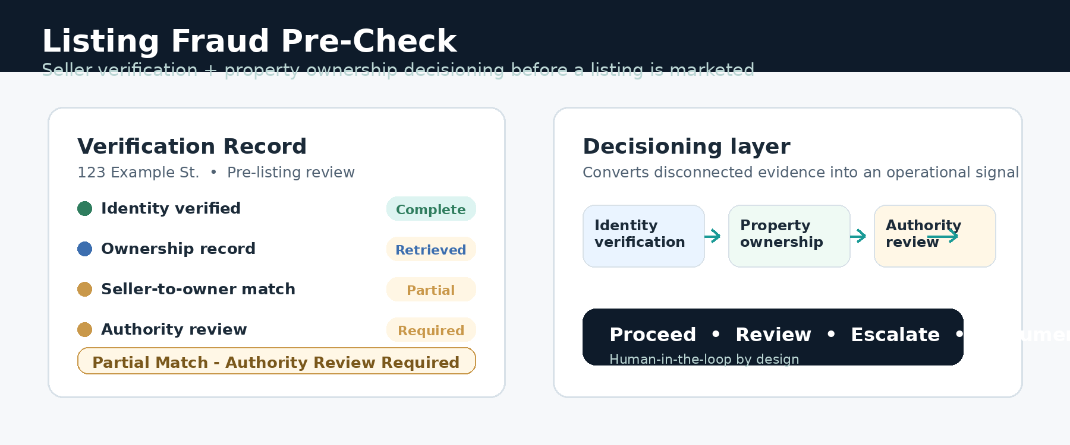
Executive summary
Listing Fraud Pre-Check turns disconnected identity, ownership, and authority information into a structured pre-listing verification workflow. The product does not replace brokers, attorneys, title companies, or fraud investigators; it gives real estate professionals an earlier signal: proceed, review, escalate, or require more documentation.

What this demonstrates: 0-to-1 product strategy, risk decisioning, human-in-the-loop design, privacy-aware requirements, and a working MVP that can be tested with real estate operators.

WHY THIS PRODUCT EXISTS
1. The Problem
Most real estate transaction controls become strongest after a property is already under contract. But seller impersonation and fraudulent listing activity can begin much earlier - when someone first approaches an agent claiming the right to sell a property.
By that point, an agent or brokerage may already be preparing listing agreements, researching price, entering MLS data, marketing the property, coordinating showings, and communicating with attorneys or title companies.
Product question
Can an agent or brokerage establish a reasonable level of confidence that the person requesting a listing is both who they claim to be and connected to the property they are attempting to sell - before the listing is marketed?

Primary users
User | Need / role in workflow
Agent | Initiates the verification process and needs a clear answer without becoming a fraud investigator.
Broker / Administrator | Reviews exceptions, evaluates documentation, and decides whether a questionable listing may proceed.
MLS / Association Reviewer | Can use the structured verification record in a centralized listing-review process.
Seller | Completes identity verification and provides information needed to establish relationship to the property.
Entity Representative | Provides authority documentation for LLCs, corporations, trusts, estates, or similar ownership structures.

FROM INFORMAL JUDGMENT TO REPEATABLE PROCESS
2. End-to-End Workflow
The workflow is designed around the actual listing approval path, not around a standalone ID check. It creates a verification record, sequences the checks, routes ambiguous cases to human review, and preserves a decision trail.
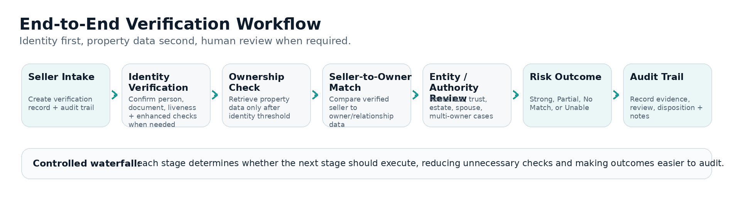
Key design principle
Identity first, property data second. A failed identity result stops the workflow before unnecessary property-data calls or additional processing occur. That sequencing reduces vendor cost and avoids continuing downstream verification for identities that already failed.
Audit trail
- what was checked and which steps completed
- summarized vendor results and system recommendation
- whether human review occurred and who made the final decision
- supporting notes, documentation, and final disposition

TURNING VERIFICATION DATA INTO AN OPERATIONAL DECISION
3. Decisioning Architecture
Individual services do not answer the full business question. An identity provider can determine whether a person appears to match an identity. A property-data provider can identify an owner of record. Neither independently answers whether a brokerage should be comfortable moving forward with the listing.
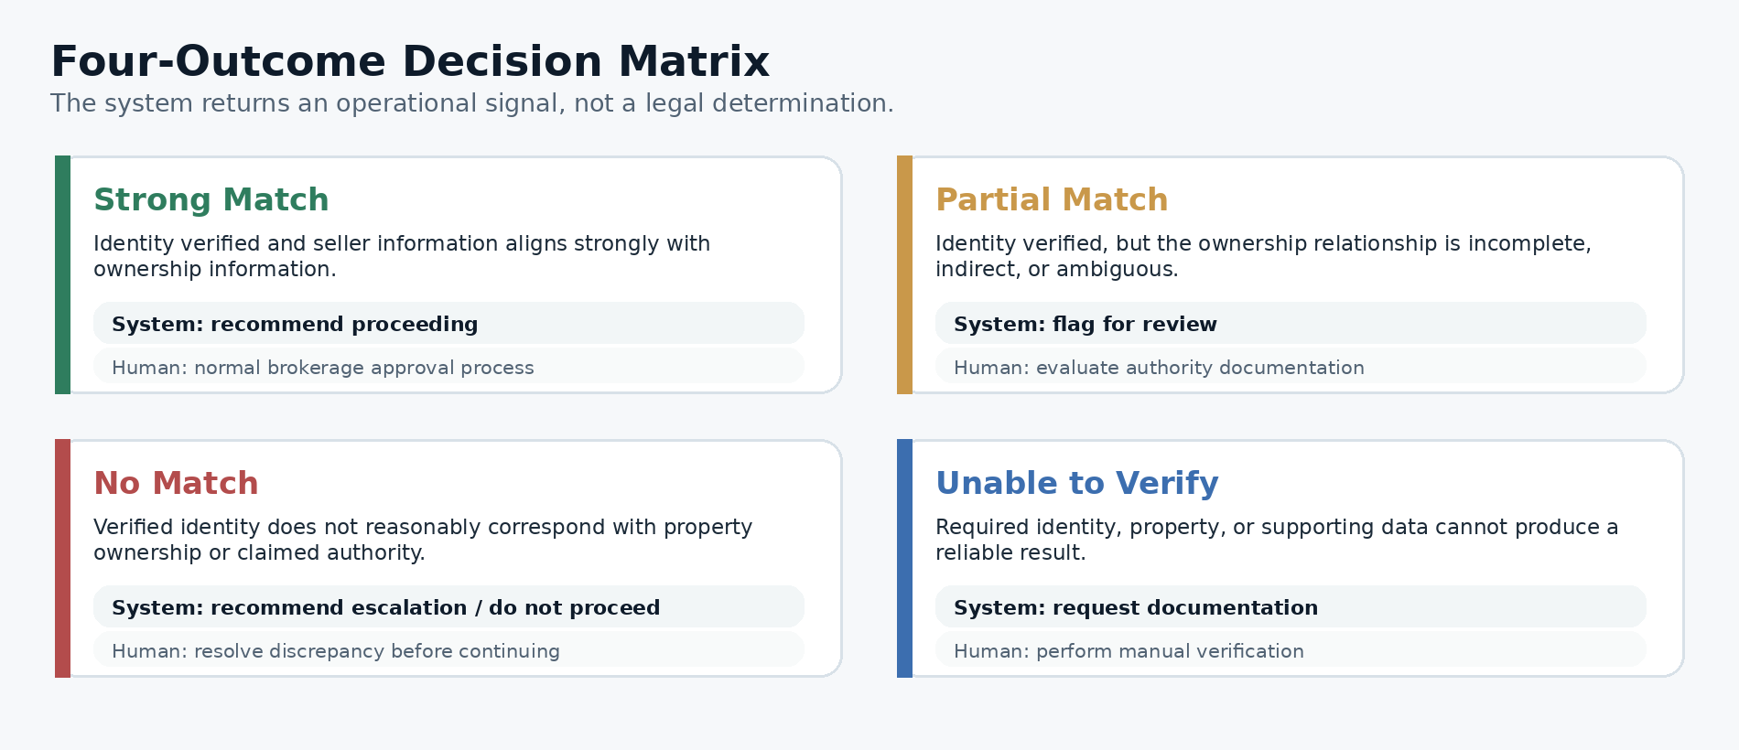
The platform is intentionally designed to preserve uncertainty. "Unable to Verify" is a valid product outcome when available data cannot produce a reliable result. The system should not manufacture certainty from incomplete, unavailable, or inconclusive information.

AUTOMATION SUPPORTS JUDGMENT - IT DOES NOT REPLACE IT
4. Human-in-the-Loop & Privacy Controls
Real estate ownership and seller authority can be complicated. The product automates evidence gathering, comparison, and risk classification while preserving broker or administrator judgment when evidence is incomplete or contradictory.
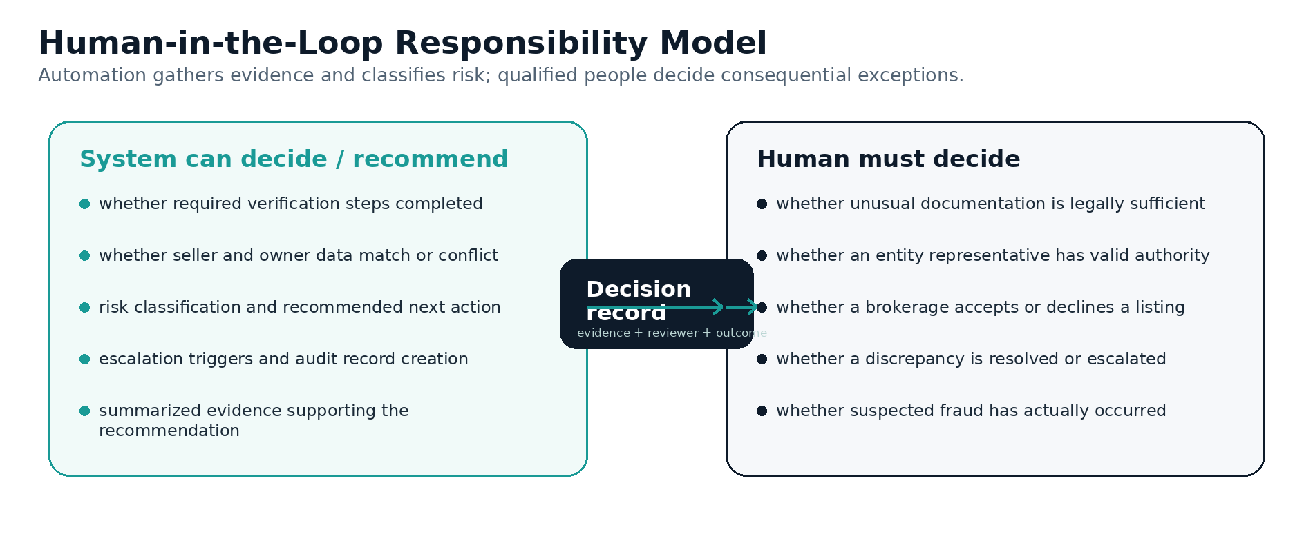
Privacy by design
Data minimization  Store only what is required to operate and document the verification workflow. | No unnecessary raw ID data  Avoid retaining complete identity documents, raw DOB information, or other sensitive information when a summarized result is sufficient.
Server-side vendor communication  Sensitive vendor interactions are designed to occur through server-side services. | Vendor-result summaries  Store actionable verification states and audit information rather than duplicating complete vendor datasets.
Role-based access  Restrict administrative functions and sensitive verification information based on user role. | Auditability  Record workflow events and review decisions so the result can be understood later.

MINIMUM SYSTEM TO TEST THE WORKFLOW
5. MVP Scope
The MVP was intentionally scoped around the core hypothesis: can seller identity and property ownership data be combined into an operational pre-listing risk decision that agents and brokers can actually use?
V1 / MVP capability | Purpose
Seller intake | Create and manage a listing-verification request.
Identity verification | Support basic identity verification with enhanced verification where required.
Property ownership retrieval | Retrieve ownership information only after identity reaches the threshold.
Seller-to-owner matching | Compare verified seller information with ownership record.
Entity / authority routing | Identify cases requiring additional documentation.
Four-state decisioning | Return Strong Match, Partial Match, No Match, or Unable to Verify.
Admin review + audit trail | Allow authorized users to review exceptions and preserve an explainable history.
Reports + access controls | Generate concise result reports and separate normal users from admin functions.
Implementation and public-demo boundary
The working MVP was developed through an AI-assisted development process using Next.js / React, Supabase, role-based authentication, secure server-side integration patterns, verification reporting, structured audit records, and a multi-tenant-ready architecture. The public demo uses deterministic sample scenarios so the workflow can be demonstrated without transmitting real consumer identity or property information.

TESTING IN A REAL LISTING ENVIRONMENT
6. Pilot Strategy & Success Metrics
The next step is a controlled pilot with an MLS, REALTOR association, brokerage, or multi-office real estate organization. The pilot should focus on a defined population of listings rather than requiring organization-wide adoption on day one.
Time to verify  Fast enough that fraud prevention does not become a barrier to legitimate listings. | Clean approval rate  Percentage of legitimate listings that produce Strong Match without admin intervention.
Manual review rate  Exception volume; a key operational metric for usability. | Escalated questionable listings  Discrepancies significant enough to require documentation or investigation.
Verification completion rate  Whether seller friction is acceptable. | Agent + reviewer adoption  Whether agents initiate the workflow and reviewers understand results quickly.
Cost per verification
Direct cost by outcome and frequency of expensive downstream data calls.
Outcome
What the product proves
Listing Fraud Pre-Check converts disconnected identity, ownership, and authority data into a simple pre-listing workflow: identity verification + property data + decisioning + human review + auditability. It automates routine cases, surfaces exceptions, and gives brokers and MLS organizations a more defensible process for deciding what happens next.

This case study demonstrates the kind of product work I am most interested in: taking a messy real-world workflow, identifying critical decision points, turning them into clear requirements and decision logic, and using modern technology and AI-assisted development to move rapidly from concept to product that can be tested with actual users.

